All about security features provided by a banking organization:

Layer 1 - Infrastructure and network security:
Before the code even runs, the environment it lives in must be locked;
- Virtual Private Cloud (VPC) and Segmentation:
  - Host your program in a VPC.
  - Segment your network so that the web servers, application logic, and databases are in separate subnets.
  - The database should be in a private subnet with NO direct internet access.
- Web application firewall (WAF):
  - It will prevent common attacks like SQL injections, Cross-site scripting (XSS), and DDoS attacks before they reach your servers.
  - Fastest way to deploy it is using a provider like cloudflare
  - 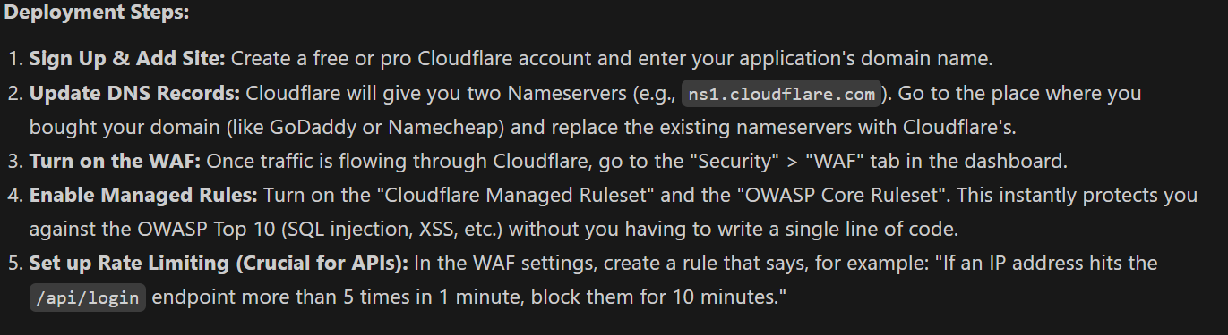
- API Gateways:
  - Useful as we have AI and chatbots in our program.
  - All API calls should be route through a centralized API Gateway that handles rate limiting (preventing brute-force attacks) and API keys validation

Layer 2 – Data Security:
This is where we safeguard transactions histories, salaries, spending patterns.
- Encryption in transit (TLS 1.3) - Any data moving between the user's mobile app/browser and your servers, or between your internal microservices, must be encrypted using the latest TLS protocols.
- Encryption at Rest (AES-256) - All sensitive data stored in your databases must be encrypted. If a hacker steals the database file, it should be unreadable gibberish.
- Tokenization and Data Masking - Never display or store full PAN numbers, Aadhaar numbers, or account numbers in plain text if you don't have to. Use tokens in your backend, and mask data in the UI (e.g., XXXX-XXXX-XXXX-1234).
- Hardware security modules (HSM) / Key management services (KSM) –
  - Do not hardcode encryption in your code
  - Use a dedicated KMS (like AWS KSM/ Azure key vault) to securely manage and rotate cryptographic keys.

Layer 3 - Identity & Access Management (IAM)
Controlling who gets to see what data, ensuring users are who they claim to be, and preventing unauthorized access.
- Multi-factor authorization: Passwords are not enough. Require an OTP (via SMS/Email), an Authenticator App, or Biometrics (Fingerprint/FaceID) for logins and high-value transactions.
- Session Management: Implement strict session timeouts. If a user is inactive for 5 minutes, log them out. Invalidate session tokens upon logout or password changes. Use secure, HttpOnly cookies to prevent session hijacking.
- Role-based access control (RBAC): For the administrative/bank-employee side of the app, ensure strict RBAC. A customer support agent should only see the data necessary to resolve a ticket, not the user's entire financial history.
- Zero trust architecture: Do not trust any user or service just because they are inside your network. Authenticate and authorize every single request

Layer 4: Application Security (Securing the Code)
Hackers often exploit poorly written data to extract data.
- OWASP top 10 mitigation: Strictly follow OWASP guidelines to prevent vulnerabilities like Broken Access Control, Injection flaws, and Insecure Design.
- Input sanitization: This is especially critical for your Conversational AI / Chatbot. Hackers can use "Prompt Injection" or malicious inputs to trick the AI into revealing other users' data or executing unauthorized commands. Validate and sanitize all user inputs rigorously.
- Secure API design: Use strong authentication for APIs (e.g., OAuth 2.0 or JWT). Ensure APIs have strict authorization checks so User A cannot manipulate an API parameter to request User B's transaction history (preventing Insecure Direct Object References - IDOR).

Layer 5: Advanced & AI-Driven Security (State-of-the-Art)
This layer uses the very AI you are building to enhance security
- Behavioural biometrics: Analyse how a user interacts with the app. At what time do they usually log in? How fast do they type? If a login happens at 3 AM from a new device with erratic swiping patterns, flag it.
- Context aware step-up authentication: If the AI detects an unusual transaction (e.g., a massive loan request or a transfer to a foreign country), dynamically pause the journey and trigger a "Step-up Auth" (asking for a fresh OTP or facial scan) before proceeding.
- AI Fraud and Anomaly Detection: Since your PS mentions detecting financial stress and unusual patterns, use that same machine learning pipeline to identify account takeover attempts, money laundering, or coordinated bot attacks

Layer 6: Compliance & Ethical Safeguards (Crucial for HACKOUT '26 Judging)
The problem statement explicitly mentions regulatory readiness and ethical safeguards.
- Data localisation (RBI norms): Ensure your cloud architecture stores all Indian citizen payment and banking data physically on servers located within India.
- Consent management (DPDP act): You cannot legally build an AI to analyse spending without explicit user consent. Implement a clear, jargon-free consent screen where users opt-in to having their data analysed for "hyper-personalized recommendations." Allow them to revoke this consent at any time.
- Audit logging (SIEM): Maintain immutable logs of every sensitive action (who logged in, who accessed which API, who viewed what data). This is required for post-breach forensics and regulatory audits.

